SIMATS ENGINEERING (SAVEETHA SCHOOL OF ENGINEERING)
Course Code & Title: | ECA5604 -5G/6G COMMUNICATION | Course Faculty: | Dr.K.Sathish
Student Name: | Velamuri Bhanodhay | Reg. No.: | 192412330
Dept / Batch: | BE.ECE / 2024 | Date: | 17/7/2026
Lab Observation

Experiment 4 : OFDMA Resource Block Allocation

Objective 1: To determine the Number of Resource Blocks (RBs) allocated in an OFDMA system
based on available bandwidth and system configuration.

Matlab Code:

clc;clear
R=floor(10e6/180e3); U=1:6;
A=floor(R/6)*ones(1,6);
A(1:mod(R,6))=A(1:mod(R,6))+1;
P=A/R*100;
disp('Total Resource Blocks:'),disp(R)
disp('RB Allocation per User:'),disp(A)
subplot(211)
stem(U,A,'filled')
grid on
title('OFDMA Resource Block Allocation per User')
xlabel('User Index'),ylabel('Number of Resource Blocks')
subplot(212)
plot(U,P,'-o')
grid on
title('OFDMA Resource Block Utilization (%)')
xlabel('User Index'),ylabel('Utilization (%)')

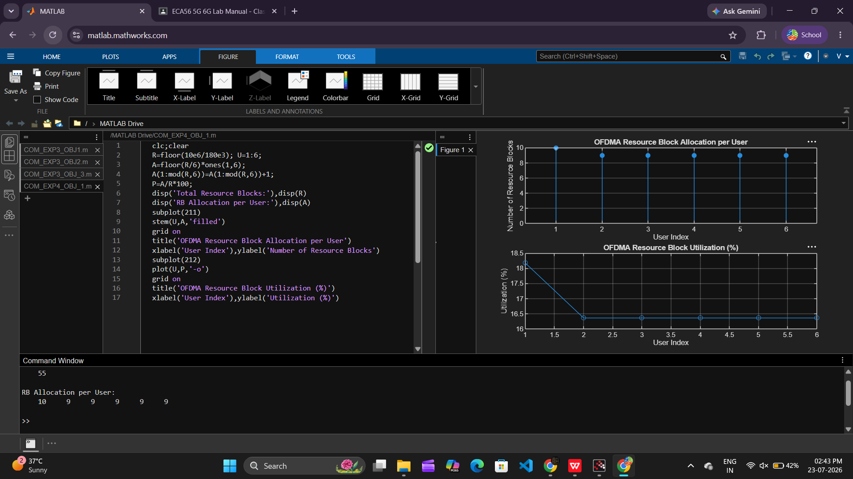

Objective 2: To evaluate the Resource Block Utilization (%) by analyzing how efficiently available
RBs are assigned to active users.

Matlab Code:

clc;clear
U=1:5; A=[12 10 9 8 11]; P=A/50*100;

disp('Resource Block Utilization (%) per User:')
disp(P')

subplot(211)
plot(U,A,'-o')
grid on
title('OFDMA Resource Block Allocation per User')
xlabel('User Index'),ylabel('Number of Resource Blocks')

subplot(212)
plot(U,P,'-s')
grid on
title('OFDMA Resource Block Utilization (%)')
xlabel('User Index'),ylabel('Utilization (%)')

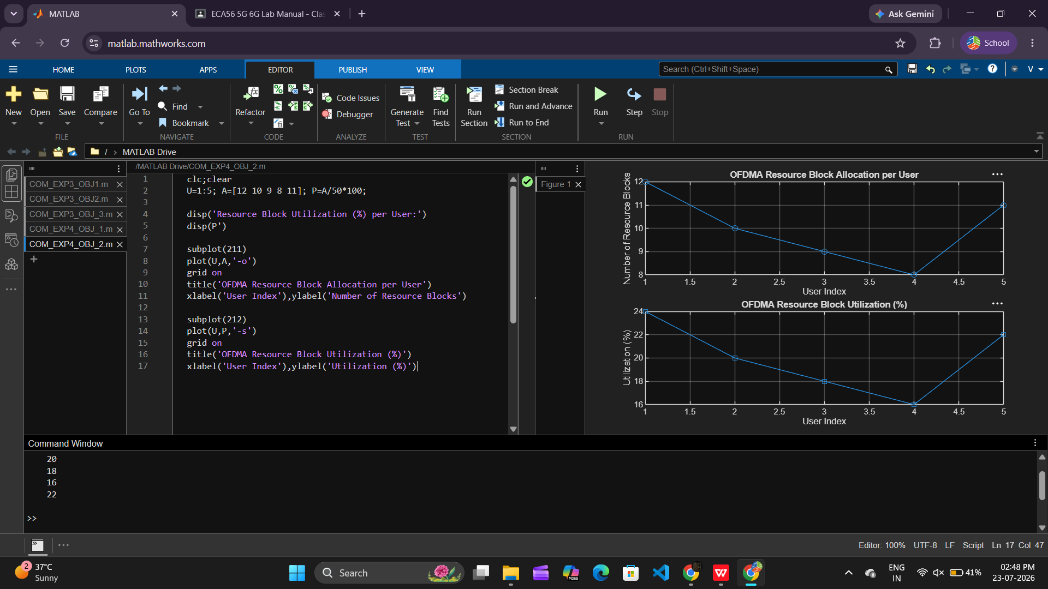

Objective 3: To calculate the User Throughput (Mbps) based on allocated resource blocks and
modulation efficiency in the OFDMA system.

Matlab Code:

clc;clear
R=[12 10 9 8 11]; M=[2 4 6 4 2]; U=1:5;
T=R.*180e3.*M/1e6;

disp('User Throughput (Mbps):')
disp(T')

subplot(211)
plot(U,T,'-o')
grid on
title('OFDMA User Throughput')
xlabel('User Index'),ylabel('Throughput (Mbps)')

subplot(212)
plot(R,T,'-s')
grid on
title('Resource Blocks vs Throughput Relationship')
xlabel('Allocated Resource Blocks')
ylabel('Throughput (Mbps)')

